**Project Title :** Natural Disaster Intensity Analysis **Project Design Phase – I:** Solution Fit Team Id : PNT2022TMID37631

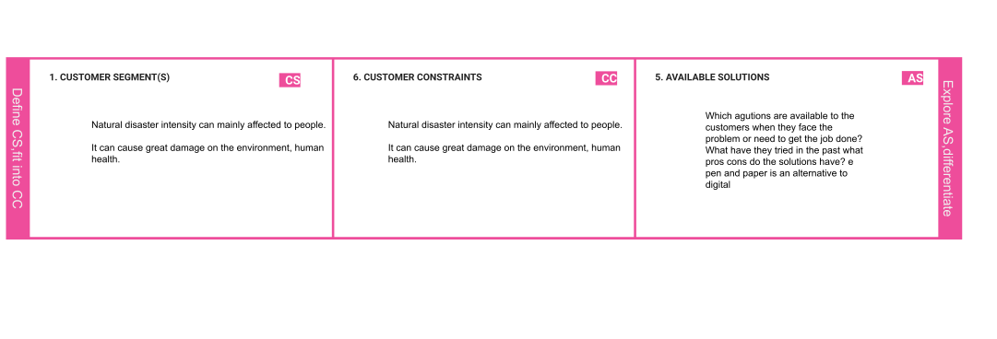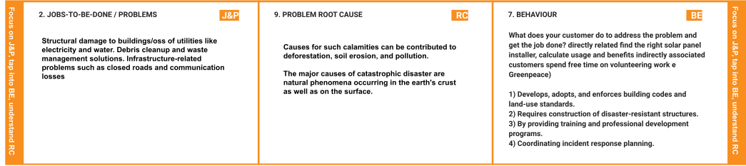

And Classification using Artificial Intelligence

|  |  |  |  |  |
| --- | --- | --- | --- | --- |
|  | **3.TRIGGERS TR**  Humans impact the physical environment in manyways: overpopulation, pollution, burning fossil fuels,and deforestation. Changes like these havetriggered climate change, soil erosion, poor airquality,andundrinkablewater. | **10.YOURSOLUTION SL**  Ifyouareworkingonanexistingbusiness,writedownyourcurrentsolutionﬁrst,ﬁllinthecanvas,andcheckhowmuchitﬁtsreality.  Ifyouareworkingonanewbusinessproposition,thenkeepitblankuntilyouﬁll in the canvas and come up with a solution that ﬁts within customerlimitations,solvesaproblemandmatchescustomerbehaviour.  **Emotionalinstability,stressreactions, anxiety,traumaandotherpsychologicalsymptomsareobservedcommonlyafterthedisasterandothertraumatic experiences.**  **Thesepsychologicaleffectshaveamassiveimpact on the concerned individual & also oncommunities.** | 1. **CHANNELSofBEHAVIOR CH**    1. **ONLINE**   Whatkindofactionsdocustomerstakeonline?Extractonlinechannelsfrom#7   * 1. **OFFLINE**   Whatkindofactionsdocustomerstakeofﬂine?Extractofﬂinechannelsfrom#7andusethemforcustomerdevelopment.  **ONLINE:**   * + 1. Theyseektechnicalsupportortheexpertsopiniononsuchmattersvia theinternet   .2)Theyorganizestrategicmeetingswithotherauthoritarianstohelpindecisionmaking.  **OFFLINE**:   * + - 1. They involve in a series of planning activities to ensure thesmoothprogressofthemonitoringandpreventingtheimpactsofthenaturalphenomenon |  |
| **4.EMOTIONS:BEFORE/AFTER EM**  **Emotionalinstability,stressreactions,anxiety,traumaandother psychological symptoms are observed commonly afterthedisasterandothertraumaticexperiences.**  **Thesepsychologicaleffectshaveamassiveimpactontheconcernedindividual&alsooncommunities.** |